Lesson 6 Assignment: Electron Transfer and Reactions
- a. OA
b. OA/RA
c. OA/RA
d. RA

- (diagrams are not clear)

- If oxidation number get increase, that is an oxidation half reaction, ff oxidation number get decrease, that is a reduction half reaction.

- Reduction half-reaction (oxidation number of H (+1) turn to 0)
- Oxidation half-reaction (oxidation number of S (+0) turn to 4)
- Reduction half-reaction (oxidation number of As (+3) turn to 0)
- Reduction half-reaction (oxidation number of Fe (+3) turn to 0)
- Oxidation half-reaction (oxidation number of Pb (+0) turn to 2)

- In early stages, oxidation and reduction can be defined in the terms of removing or adding oxygen to a compound, however that is not the robust term for the oxidation and reduction.
Initially, scientists define oxidation is gain of oxygen and reduction is removing oxygen.

Fe₂O₃ + 3CO 2Fe + 3CO₂

Fe₂O_{3,} give oxygen to the CO, therefore, Fe₂O₃ considered as oxidizing agent while CO removes oxygen from the Fe₂O_{3,} therefore CO considered as reducing agent

Also, it can define with respect to the hydrogen transfer, i.e. if hydrogen loss from a substance its called oxidation while gaining of hydrogen is called reduction.
More precise definitions,
Oxidizing agents add oxygen to another substance or remove hydrogen from it.
Reducing agents remove oxygen from another substance or add hydrogen to it

However now we know define this with respect to the electron transfer,

Cu²⁺ + Mg Cu + Mg²⁺

Here, Cu(ІІ) is change the oxidation start to zero, therefore, Cu(ІІ) was reduced, hence we can consider it as oxidizing agent (if a substance subjected to the reduction that is called oxidizing agent while a substance subjected to the oxidation that is called reducing agent). However, Mg act as reducing agent, because Mg change its oxidation state 0 to +2.

- You can’t store. Because, Sn start to react with acidified potassium permanganate.
- MnO₄⁻_{(aq)} + 5 Sn_{(s)} + 32 H⁺_{(aq)} 4 Mn²⁺_{(aq)} + 5 Sn⁴⁺_{(aq)} + 16 H₂O_{(l)}

Oxidation: Zn_{(s)} Zn²⁺_{(aq)} + 2e
Reduction: Au³⁺_{(aq)} + 3e Au_{(s)}
Overall: Zn_{(s)} + Au³⁺_{(aq)} Zn²⁺_{(aq)} + Au_{(s)}
Reaction: 3 Zn_{(s)} + 2 AuCl_{3(aq)} 3ZnCl_{2(aq)} + 2Au_{(s)}

Cl₂ _{(g)} + H₂ _{(g)} 2 HCl_{(aq)}
NaOH_{(aq)} + HCl_{(aq)} NaCl_{(aq)} + H₂O_{(aq)}
Oxidation states of NaOH {Na (+1), O (-2), H (+1)}
Oxidation states of HCl {H (+1), Cl (-1)}
Oxidation states of NaCl {Na (+1), Cl (-1)}
Oxidation states of H₂O {H (+1), O (-2)}

- Oxidation: H₂O_{2(aq)} O_{2(g)} + 2e +2H⁺_{(aq)}
Reduction: ClO₄⁻_{(aq)} + 8e + 8H⁺_{(aq)} Cl⁻_{(aq)} + 4H₂O_{(aq)}
Overall: ClO₄⁻_{(aq)} + 4H₂O_{2(aq)} 4O_{2(g)} + Cl⁻_{(aq)} + 4H₂O_{(aq)}
Reaction: HClO_{4 (aq)} + 4H₂O_{2(aq)} 4O_{2(g)} + HCl _{(aq)} + 4H₂O_{(aq)}

- Oxidation: Cu_{(s)} Cu²⁺_{(aq)} + 2e
Reduction: 2H⁺_{(aq)} + 2e H_{2(g)}
Overall: Cu_{(s)} + 2H⁺_{(aq)} Cu²⁺_{(aq)} + H_{2(g)}
Reaction: Cu_{(s)} + 2HCl _{(aq)} CuCl_{2(aq)} + H_{2(g)}

- No. That reaction not proceeds well. Because, reduction potential of the reactant receiving the electrons must be lower than the reduction potential of the reactant giving up electrons. The electrode reduction potential of the hydride is 0 V. The reduction potential of the copper is -0.34 V. This means that the copper is not removed its electron, despite the hydride is pulling electrons toward it, thus no reaction will take place.

- Na_{(s)} + H₂O_{(l)} NaOH_{(aq)} + H_{2(g)}

Test 1
We can use an Acid-Base reaction to identify the NaOH. We can take a potion from the product solution and perform an acid-base reaction.
NaOH_{(aq)} + HCl_{(aq)} NaCl_{(aq)} + H₂O_{(l)}

First, we check pH of the selected portion using pH paper and then same amount of HCL to the selected portion and finally, checked the pH. We can observe initial basic pH going to be decrease due to the acid-base reaction.
Test 2
Take another portion of a product solution and add little aluminum sulphate to it. We can see white color ppt underneath of the vessel.
Al₂(SO₄)_{3(aq)} + 6NaOH_{(aq)} 2Al(OH)_{3(s)} + 3Na₂SO_{4(aq)}

Test 3
Take the remaining portion and Al foils to it. Then top of the vessel is covered with a mouth of a balloon. Then we can see balloon start to blowing up, that is because of evolve hydrogen gas from the reaction between Al and NaOH.
2 Al_{(s)} + 2 NaOH_{(aq)} + 6 H₂O_{(l)} 2 NaAl(OH)_{4(aq)} + 3H_{2(g)}

Lesson 7 Assignment: Redox Applications
- Oxidize
- Suppose a reaction of potassium permanganate with hydrogen peroxide. Here, hydrogen peroxide subjected to the oxidation, so its calls reducing agent. And potassium permanganate is called oxidizing agent.
Oxidation: H₂O₂ _{(aq)} O_{2(g)} + 2e + 2H⁺_{(aq)}

- a. Oxidizing agent – Potassium permanganate
Reducing agent – tin(ІІ) chloride
b. initial purple color gets faded and become colorless at the end point.
c. tin(ІІ) chloride

- Oxidation: Sn²⁺_{(aq)} Sn⁴⁺_{(aq)} + 2e
Reduction: MnO⁴⁻_{(aq)} + 5e + 8H⁺_{(aq)} Mn²⁺_{(aq)} + 4H₂O_{(l)}
Overall: 5Sn²⁺_{(aq)} + 2MnO⁴⁻_{(aq)} + 16H⁺_{(aq)} 5Sn⁴⁺_{(aq)} + 2Mn²⁺_{(aq)} + 8H₂O_{(l)}
Reaction: 5SnCl_{2(aq)} + 2KMnO_{(aq)} + 16HCl_{(aq)} 5SnCl_{4(aq)} + 2MnCl_{2(aq)} + 8H₂O_{(l)}

- a. Not redox
b. not redox
c. not redox
d. redox

- a. P = +5
b. P = -3
c. P = +5
d. P = +5

- Au(NO₃)_{3(aq)} will turn to [Au(OH)₄]⁻_{(aq)}
Then redox reactions
Oxidation: H_{2(g)} + 2OH⁻_{(aq)} 2H₂O_{(l)} + 2e
Reduction: Au³⁺_{(aq)} + 3e Au_{(s)}
Overall: 3H_{2(g)} + 2Au³⁺_{(aq)} + 6OH⁻_{(aq)} 6H₂O_{(l)} + 2Au_{(s)}

- NaIO_{3(aq)} + 5NaI_{(aq)} + 6HCl_{(aq)} 6NaCl_{(aq)} + 3I_{2(s)} + 3H₂O_{(l)}
Oxidation numbers, NaIO₃ – I = +5
NaI – I = -1
I₂ = 0

- 6 mol

- Reducing agent is Na_{(s)}. heat production is proportional to the molar ratio of the equation
(729.5 kJ/2 mol) * 0.235 mol = 85.72 kJ

Lesson 11 Assignment: Water's Balance of Power
Part A: Multiple Choice
Question No | Answer
1 | B
2 | B
3 | 0.015 mol/L
4 | 5 * 10⁻¹⁴ mol/L
5 | [H+] = 1 * 10⁻⁵ mol/L , [OH⁻] = 1 * 10⁻⁹ mol/L

Part B
C₆H₅COOH_{(aq)} C₆H₅COO⁻_{(aq)} + H⁺_{(aq)}

K_{a} = {[ C₆H₅COO⁻_{(aq)}] * [H⁺_{(aq)}]}/ [C₆H₅COOH_{(aq)}]
In dissociation, [ C₆H₅COO⁻_{(aq)}] = [H⁺_{(aq)}], so [H⁺_{(aq)}] = x
K_{a} = 6.5 x 10⁻⁵ mol/L
K_{a} = x² / (0.015 – x)
6.5 x 10⁻⁵ = x² / (0.015 – x)
x² + 6.5 x 10⁻⁵ x – 9.75 * 10⁻⁷ = 0
Solve for x using the quadratic equation: x = [-b ± (b² - 4ac)^{½}]/2a
x = {-6.5 x 10⁻⁵ + [(6.5 x 10⁻⁵)² + 4(0.015)(6.5 x 10⁻⁵)]^{½}}/2
x= 6.88 * 10⁻⁵ mol/L
[H⁺_{(aq)}] = 6.88 * 10⁻⁵ mol/L
Find pH
pH = -log[H⁺]
pH = -log(x)
pH = -log(6.88 x 10⁻⁵)
pH = -(-4.16)
pH = 4.16

7. a.
CH₃COOH_{(aq)} CH₃COO⁻_{(aq)} + H⁺_{(aq)}
pH = -log[H⁺]
2.435 = -log[H⁺]
[H⁺] = 3.67 * 10⁻³ mol/L
Ka of acetic acid is 1.8 * 10⁻⁵ mol/L
As mention above, initial concertation can be taken as C
K_{a} = {[ CH₃COO⁻_{(aq)}] * [H⁺_{(aq)}]}/ [CH₃COOH_{(aq)}]
1.8 * 10⁻⁵ = {(3.67 * 10⁻³)^2}/ (C - 3.67 * 10⁻³)
C - 3.67 * 10⁻³ = 0.749
C = 0.745 mol/L
Concentration of acetic acid is 0.745 mol/L
b.
mass of acetic acid = 60 g/mol
mass of acetic acid in the L sample = 60 * 0.745 = 44.74 g/L
mass of acetic acid in the 100 ml sample = 4.47 g

c. percent error
(5 – 4.47) g / 5 g = 0.105
0.105 * 100 = 10.5%
Percent error = 10.5 %

8
HF_{(aq)} + H₂O_{(l)} H₃O⁺_{(aq)} + F⁻_{(aq)}
pH = -log[H⁺]
2.080 = -log[H₃O⁺]
[H₃O⁺] = 8.31 * 10⁻³ mol/L
Ka of HF acid 6.6 *10⁻⁴ mol/L
K_{a} = {[ F⁻_{(aq)}] * [H₃O⁺ _{(aq)}]}/ [HF_{(aq)}]
6.6 * 10⁻⁴ = {(8.31 * 10⁻³)^2}/ (C - 8.31 * 10⁻³)
C - 8.31 * 10⁻³ = 0.104
C = 0.113 mol/L
Dissociate concentration of HF is 0.113 mol/L
Mass of HF 20.01 g/mol
Dissociation mass of HF = 20.01 * 0.113 = 2.26 g/L
Therefore, mass dissociate in 2L of water = 4.52 g
Percent ionization is = {4.52/8} * 100 =56.59 %

Lesson 11 Assignment: Water's Balance of Power
Part B: Written Response
9. Concentration of methanoic acid in a bite
pH = -log[H⁺]
2.456 = -log[H₃O⁺]
[H₃O⁺] = 3.5 * 10⁻³ mol/L
Molar mass of the formic acid = 46 g/mol
Mass of formic acid in bite = 46 * 3.5 * 10⁻³ = 0.160 g/L
Therefore, mass of formic acid present in the 1.0 * 10⁻⁵ ml = 1.6 *10⁻⁶ g = 1.6 µg

11. Initially, white crystalline precipitate is formed
CH₃COOH_{(aq)} + AgNO_{3(aq)} CH₃COOAg_{(s)} + H⁺_{(aq)} + NO₃⁻_{(aq)}
AgNO₃ is not completely soluble in the CH₃COOH, therefore, it’s slightly soluble in the CH₃COOH, hence it forms a crystalline precipitate.
CH₃COOH_{(aq)} CH₃COO⁻_{(aq)} + H⁺_{(aq)}
K_{a} = {[ CH₃COO⁻_{(aq)}] * [H⁺_{(aq)}]}/ [CH₃COOH_{(aq)}]
In dissociation, [ C₆H₅COO⁻_{(aq)}] = [H⁺_{(aq)}], so [H⁺_{(aq)}] = x
And [CH₃COOH_{(aq)}] = 8.3 *10⁻³ mol/L
K_{a} = 1.8 * 10⁻⁵ mol/L
K_{a} = x² / 8.3 *10⁻³
1.8 * 10⁻⁵ = x² / 8.3 *10⁻³
X² = 1.5 * 10⁻⁷
X = 3.87 * 10⁻⁴ mol/L
Therefore, [H⁺_{(aq)}] = 3.87 * 10⁻⁴ mol/L
pH = -log[H⁺]
pH = -log (3.87 * 10⁻⁴)
pH = 3.41
c. temperature – we can measure the temperature at different time when the reaction proceeds and measure the pH of the reaction mixture using pH probe. We can change the temperature by putting Bunsen burner underneath of the reaction mixture.
d. initially measures the temperature and pH before adding the silver nitrate to the acetic acid, then slowly add acetic acid allow reaction to proceeds. Then at specific time interval (5 min, 8 min, etc.) measure the temperature and pH in each time intervals. Then, tabulate those data and draw a plot temperature vs pH. Finally, we can identify how pH behave when the reaction proceeds with the variation of temperatures.

Lesson 12 Assignment: Acid-Base Theories
Part A: Multiple Choice
- D
- B
- C
- B
- A
- C
- C
- C

Part B: Written Response
- Because when H⁺ ions are present in the water, H⁺ ions can polarize the electron cloud in water molecule, therefore, electron cloud of water molecule get distorted and form a ionic nature on water molecules, hence, H⁺ get attracted to the distorted electron cloud and make chemical bond between polarize electron cloud and H⁺ ion. Therefore, H₃O⁺ ions are formed.

- Week bases such as NH₃ like bases are not considered as bases in Arrhenius theory.
It did not explain the behavior of acids and bases in non-aqueous solutions
- a.
CO_{2(g)} + H₂O_{(l)} H₂CO_{3(aq)}
H₂CO_{3(aq)} + H₂O_{(l)} HCO⁻_{3(aq)} + H₃O⁺_{(aq)}
HCO⁻_{3(aq)} + H₂O_{(l)} CO²⁻_{3(aq)} + H₃O⁺_{(aq)}

b.
HCN_{(aq)} + H₂O_{(l)} CN⁻_{(aq)} + H₃O⁺_{(aq)}
c.
Li₂O_{(aq)} + H₂O_{(l)} Li²⁺_{(aq)} + O²⁻_{(aq)}
O²⁻_{(aq)} + H₂O_{(l)} 2HO⁻_{(aq)}
- a. CH₃COOLi_{(aq)} + NH₄Br_{(aq)} CH₃COONH_{4(aq)} + LiBr_{(aq)}
b. CaHPO_{4(aq)} + 2CH₃COOH_{(aq)} (CH₃COO)₂Ca_{(aq)} + H₃PO_{4(aq)}
c. HBr_{(aq)} + NH_{3(aq)} NH₄Br_{(aq)}

Lesson 12 Assignment: Acid-Base Theories

Part B: Written Response
- Because when H⁺ ions are present in the water, H⁺ ions can polarize the electron cloud in water molecule, therefore, electron cloud of water molecule get distorted and form a ionic nature on water molecules, hence, H⁺ get attracted to the distorted electron cloud and make chemical bond between polarize electron cloud and H⁺ ion. Therefore, H₃O⁺ ions are formed.

- Week bases such as NH₃ like bases are not considered as bases in Arrhenius theory.
It did not explain the behavior of acids and bases in non-aqueous solutions
- a.
CO_{2(g)} + H₂O_{(l)} H₂CO_{3(aq)}
H₂CO_{3(aq)} + H₂O_{(l)} HCO⁻_{3(aq)} + H₃O⁺_{(aq)}
HCO⁻_{3(aq)} + H₂O_{(l)} CO²⁻_{3(aq)} + H₃O⁺_{(aq)}

b.
HCN_{(aq)} + H₂O_{(l)} CN⁻_{(aq)} + H₃O⁺_{(aq)}
c.
Li₂O_{(aq)} + H₂O_{(l)} Li²⁺_{(aq)} + O²⁻_{(aq)}
O²⁻_{(aq)} + H₂O_{(l)} 2HO⁻_{(aq)}

Lesson 13 Assignment: Visualizing the Acid-Base Solution

Part A: Multiple Choice
- A
- (not visible)
- C
- D
- C
- B
- D
- B

Part B: Written Response
- Equivalence point is the point where number of titrant moles equal to the number of moles of the analyte, whereas endpoint occurs after the equivalence point but can occur concurrently depending on the pH. Equivalence point indicates the end of the reaction, however, end point not always give the end point of the reaction, but it gives the color change of the reaction. Nevertheless, equivalence point doesn’t always indicate the color change of the reaction mixture.

Similarities | Differences
Titration always start from the higher pH value (close to 14) | Strong acid-Strong base titration curve always pass through lower pH values, but strong base-weak acid titration curves not extended to that much
Always steep slope can be seen | The equivalence point of the strong acid-strong base titration curve lies at pH 7, however, strong base-weak acid titration curves does not lie at pH 7

- a.
Takes a known volume of an unknown solution and then titrate with 0.1 mol/L NaOH, while titrating records the pH values. And when pH value become to steady record the consume volume of NaOH for the titration. And follow the same procedure for the remain to also. Finally, draw the respective pH curves for the titration.

b. we can obtain three different pH curves. One curve is touching the lower pH values (close to pH value of 1, 2), as well as consume volume of NaOH is equal to the measured analyte volume, hence that is responsible for the strong acid-strong base type titration. Therefore, that acid is HI
one of the remain graph shows two slopes in the pH curve, therefore that is polyprotic acid. Hence, we can conclude it as HOOCCOOH acid. And remain one is CH₃COOH.

- KOH_{(aq)} + CH₃CHOOH_{(aq)} CH₃CHOO⁻_{(aq)} + K⁺_{(aq)} + H₂O_{(l)}
- HI_{(aq)} + NH_{3(aq)} NH₄⁺_{(aq)} + Cl⁻_{(aq)} + I⁻_{(aq)}

Part 1
Question Topics:
1. Fractional distillation – This is works according to the boiling points of molecules. Different molecules have different boiling points due to their different molecular mass. Generally, smaller molecules have lower mass therefore, they have lower boiling points. When heating up a mixture of molecules, the lower mass compounds evolve first from the mixture, while other compounds need higher temperature to boil off. According to the boiling points of the molecules present in the mixture, temperature will increase step by step to evolve compound from one-by-one.
Purpose of cracking process – when oil mixtures subjected to the fractional distillation, oil mixtures contain large hydro carbons, therefore, we need to supply large amount of heat to distillation. To avoid that we need to crack the larger hydrocarbon molecules into smaller ones. Sometimes there are insufficient number of smaller hydrocarbons, so we need to meet the demand of smaller hydrocarbons, that is also a major reason for introduce cracking into distillation.
For instance,
C₆H₁₄ C₄H₁₀ + C₂H₄
Purpose of reforming process – This is used to improve the octane number of the petrol and make aromatic hydrocarbons to chemical industries. In here, using a catalyst chain molecule get converted to the aromatic hydrocarbons.
For instance,
Hexane Benzene

2. saturated hydrocarbon are insufficient with the reaction centers to react with other compounds. Doble bonds, triple bonds, carbonyl groups, etc. act as reaction centers in hydrocarbons. Therefore, to occur a reaction there should be a reaction center present in the hydro carbon.
For instance,
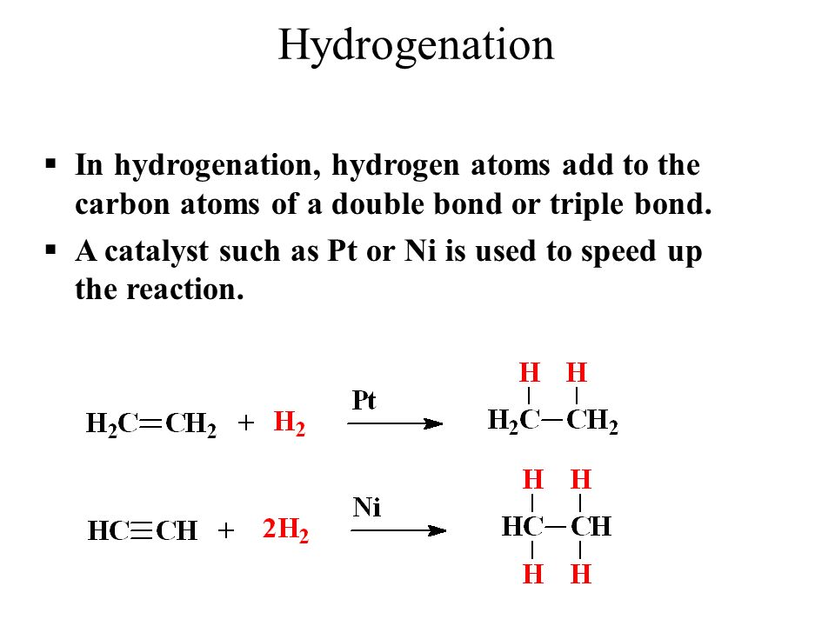
(https://slideplayer.com/slide/9631525/)
B.
A. Ethanol (primary hydrocarbon)
B. 2-Propanol (secondary hydrocarbon)
C. 2-methyl-2-propanol (tertiary hydrocarbon)

Part 4
1)

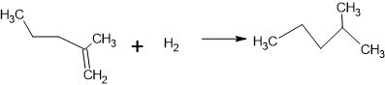

2.

3. 2C₂H_{2(g)} + 5O_{2(g)} 4CO_{2(g)} + 2H₂O_{(l)}

4.

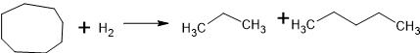

Part II
Name the following compounds and give the group name that each of them belongs to
5. CH₃CH₂CH₂COCH₂CH₃ – 2-heptone (ketone)
6. CH₃CH₂COOH – Propanoic acid (carboxylic acid group)

